Name: Alexis Rudy
Date: 1/20/2022

Burn Lab
Use this worksheet to capture the results of your burn lab, including pictures. Refer to The Burn Test chart from Threads magazine to identify the fabric.
BE CAREFUL!
Fabric 1  Insert picture of fabric swatch | 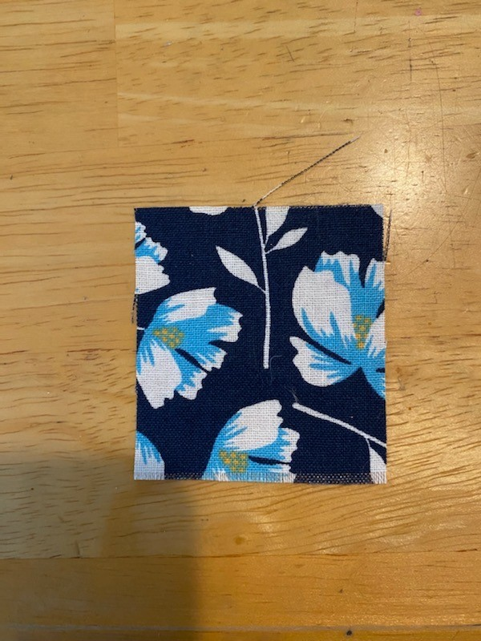
Behavior of the fabric as it approached the flame | Normal
Behavior of the fabric in flame | Caught fire and burned quickly
Behavior of the fabric when removed from flame | Continued to burn with ease
Describe odor (don't smell until cool!) | Campfire smell
Describe the ash | Burnt; paper-like ash
Picture of burning fabric OR the resulting ash | 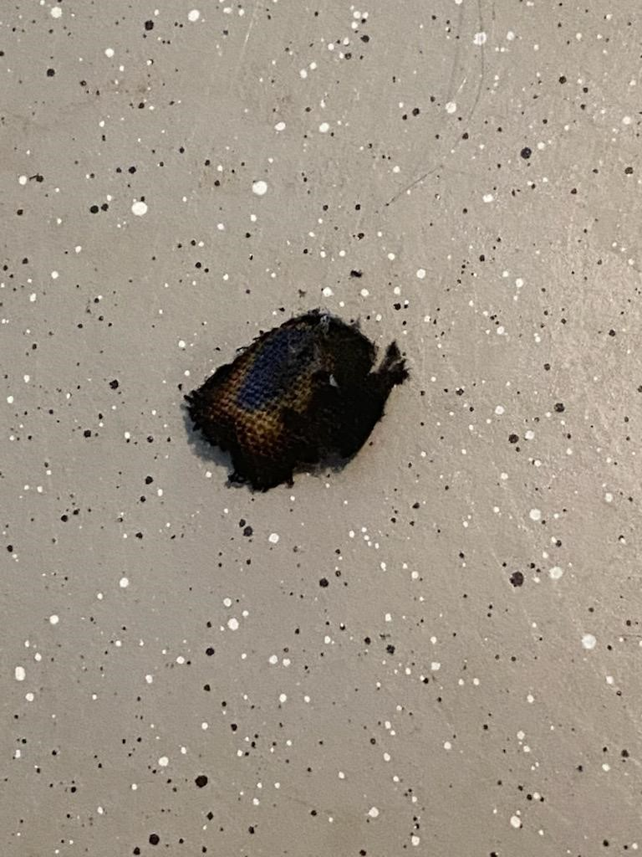
What type of fabric did you test? | cotton

Fabric 2  Insert picture of fabric swatch | 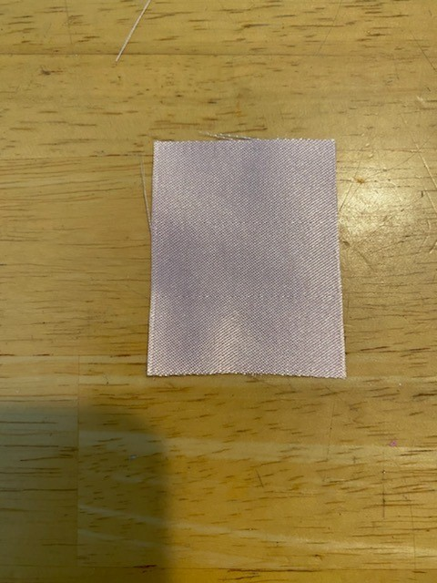
Behavior of the fabric as it approached the flame | Melted away; fused together
Behavior of the fabric in flame | Difficulty burning
Behavior of the fabric when removed from flame | Melted; fire went out
Describe odor (don't smell until cool!) | Plastic; synthetic
Describe the ash | Hard black bead
Picture of burning fabric OR the resulting ash | 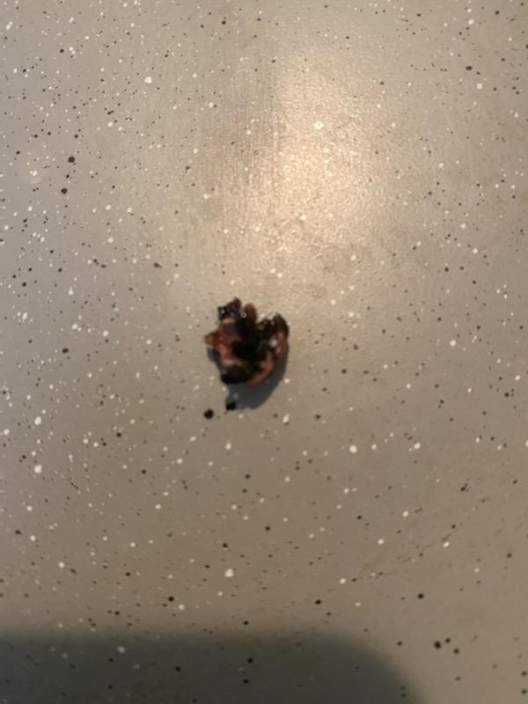
What type of fabric did you test? | polyester

Fabric 3  Insert picture of fabric swatch | 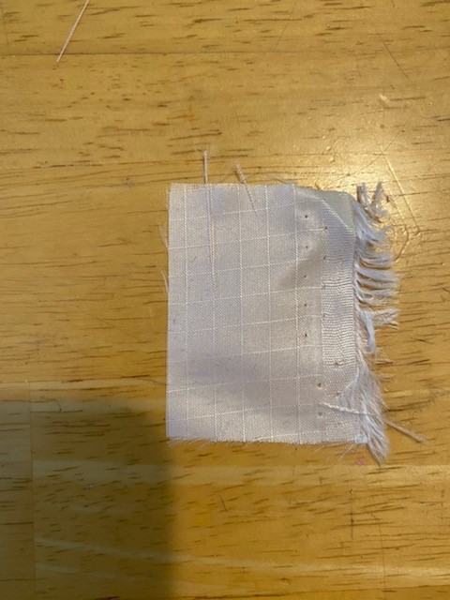
Behavior of the fabric as it approached the flame | Melts away
Behavior of the fabric in flame | Melts; sizzles
Behavior of the fabric when removed from flame | Melted like tar
Describe odor (don't smell until cool!) | Synthetic
Describe the ash | Grey; hard bead
Picture of burning fabric OR the resulting ash | 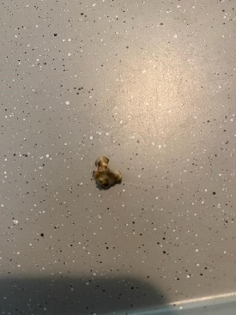
What type of fabric did you test? | nylon

Fabric 4  Insert picture of fabric swatch | 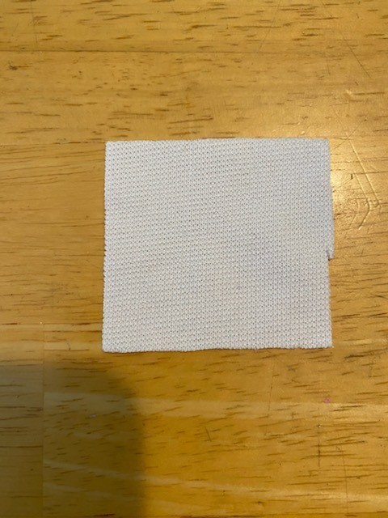
Behavior of the fabric as it approached the flame | Melted together; shrinks away
Behavior of the fabric in flame | Fuses down; melts; sputters
Behavior of the fabric when removed from flame | Melts; fire dies out
Describe odor (don't smell until cool!) | Plastic
Describe the ash | Hard black bead
Picture of burning fabric OR the resulting ash | 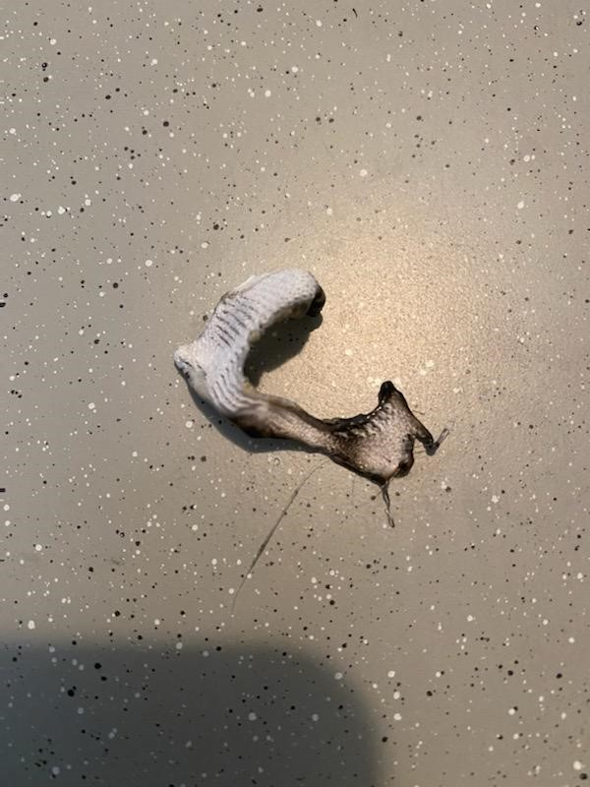
What type of fabric did you test? | acetate

